. 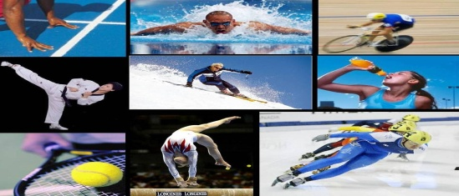 Optimum Health & LIFE Performance Centers
OPTIMIZE YOUR HEALTH AND MAXIMIZE LIFE PERFORMANCE

We Are Comprised Of A Very Successful Team Of Experienced; Wellness Coaches, Natural Health Care Practitioners, Physical Training Experts, Rehabilitation Specialist, Martial Arts Trainers & Instructors & Supplemental Nutrition - Sales Consultants Who Will Undoubtedly Enhance Your View Into Not Only Well Being, Fitness & Athletic Performance, But Collectively The Astronomical "SPORT OF LIFE" Itself. LOOK, FEEL, AND PERFORME BETTER THEN YOU EVER THOUGHT POSSIBLE TODAY…
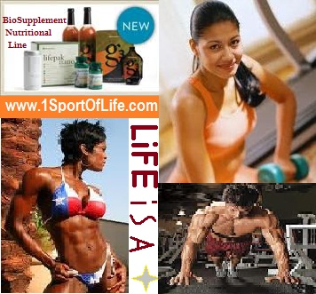
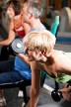
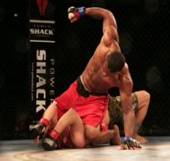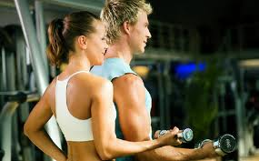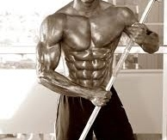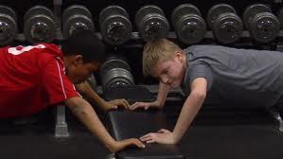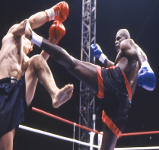
@ 1’SPORT OF LIFE, YOU WILL FIND;
- Natural Healing Consultants
- Naturopathic Doctors & Other Natural Health Care Practitioners "Address The Underlining Causes, Not The Symptoms”…N
- Nutritionist
- Master Herbalist
- Personal Trainers & Fitness Instructors
* No Matter 90 minutes, 60, or even 10.. “SO NO MORE EXCUSES”
- Sports Specific Training ("Train The Way You Play")
- Strength & Conditioning Coaches
- Traditional Martial Arts Instructors
* Tae Kwon Do
* Brazilian Jujitsu
* Kajukenbo
* Kenpo Karate
* Kung Fu San Soo
* …And More…
- (Mixed Martial Arts) Training & Coaching
- G’NAMIC Elite Strike Force
- * Boxing (American & Chinese)
- * Kick Boxing (American & Muay Thai)
- * Submission Wrestling/Grappling
- * Ground & Pound

WE DEVISE CUSTOM PROGRAMS CONSISTING OF;
- Age Defying Anti-Oxidization Formulas
- Muscle Structuring Amino Acids
- Bone Reconditioning Calcium Formulas
- Digestive Health
- Energy & Vitality
- Waste Moving Fiber Supplements
- Gourmet Herbal Tea Blends
- Sport Of Life - News Letter
- Heart-Healthy Formulas
- Joint & Cartilage Repair
- Women's Health
- Men's Health
- B-Complex Formulas
- Weight Management
- Herbal Supplements
- Mental - Health & Performance
- Mineral Formulas
- Dialysis Replenishment Formula
- Elite Multi-Vitamins & Mineral Formulas
- Natural & Whole Food Supplements
- Nutritional Hair-Care
- Nutritional Skin-Care
- Protein Supplements
- Healthy Sleep Support
- Sports Performance Nutrition
- Targeted Goal Specific Multi-Nutritional Program Kits
- Superior Immune Boosting Formulas With Vitamin C
- Cell Repairing Vitamin D Formulas
- Cell Protecting Vitamin E Formulas
- Life Extension Anti-aging Formulas
- Supper Green Food Formulas
- Phytonutrients
- Trace Minerals
- Real Fruit Power & Vitality Smoothies (available for clients only) in store
- Fresh Raw Organic Supper Green Drink (available for clients only) in store•
- Natural Healing Herbal Formulas And Protocols
1’SPORT OF LIFE &
G’NAMIC - Elite Strike Force
Apparel Also Available…

*FREE COUNSULTATIONS*

Get Off Prescription Drugs & Successfully Battle Ailments Like;
High Blood Pressure
High Cholesterol
Diabetes
Cancer
HIV & AIDS
Lupus
Fibromyalgia
Herpes
Anemia
Arthritis
…And Many, Many More...........

Pay-As-U-Go 4 Elite 1-On-1 ($50) Per Session Group Rates Per Person; 2-4 ($40) or 5 Plus ($15)
OR
Become A Monthly Member, @ 1 Low Rate, And Receive An Amazing Comprehensive Customized Program Featuring;
FREE - Customized Meal Planning
FREE - Vitamins, Minerals, Herbs, Customized Condition Specific- Natural Performance
Enhancement- Weight Loss, and many other Supplements.
FREE - Access To Our 24hr Member Nutrition, Health Related Q&A, Meal Regiment Options, Healthy
Recipes From All Over The World, Natural Healing Aids & Protocols and Other Continued
Related Educational News Updates Support Network. (via phone, online and/or email)
U Will Also Receive A FREE Membership Into G’NAMIC- Divisions Group Including The Following Additional Monthly Member Advantages
* FREE * - Additional Training Sessions … Tae Kwon Do Class (1 per month) … Jujitsu Class (1 per month) … CQC -Close Quarters Combat [Law Enforcement & Military Influenced]- (1 per month)
* FREE * Vehicle Diagnostics (unlimited)
* FREE * Oil Changes (2-4 per year)
* FREE * Menu Options @ Participating Network Restaurants (1 visit per month)
* FREE * Cosmetology & Spa Services … Hair Spa Wash & Conditioner (1 per month) … Herbal Growth Stimulating Hair & Scalp Treatments (1 per month)
* FREE * Organic & Natural Soaps, Lotions, Creams, Face Bars, Body Oils & More...
* FREE * Academic Tutoring, Foundational Health Education, Dance, Vocal, Music, Instruments, & … Other Performing Arts lessons For Your Child (5 To 20 Instructions/Lectures per month)
* PLUS * ...Dozens Of Other FREE & DISCOUNTED Products And Services Still To
Come Within Our Always Growing Network Of Goods & Service Providers

*Membership Requires A Minimum 3 Month Commitment*
JOIN TODAY @ One Of The Following:
1’ SPORT OF LIFE – Health & Fitness Training Center @ BLACK BELT Institute Located @
13933 Hawthorne Blvd. Hawthorne, Ca. 90250 Phone: (310) 502-4861
www.1sportoflife.com
If You Know Of Some One Who Is Ill Stricken With Viruses, Diseases, Disorders, Crippled By Prescription Drugs, An Elderly Whom Is With Poor Quality Of Life Or Individuals Who Simply Want To Look & Feel Better. Please Share With Them Our 1’SPORT OF LIFE - Message
1‘LIFE PROSPERTY…

